# 2 – Search/Pull/Download and Manage Docker Images

Created On

Last Updated On

bycyberpanel

Print

* [Main](https://cyberpanel.net/docs/)
* [Docker Manager](https://cyberpanel.net/docs/category/docker-manager-cyberpanel/)
* 2 - Search/Pull/Download and Manage Docker Images

< All Topics

Before reading this tutorial you must read:

1. [Getting Started with CyberPanel Docker Manager.](https://cyberpanel.net/docs/1-getting-started-with-cyberpanel-docker-manager)

Once Docker is installed, you are ready to search and find images.

### Manage Images

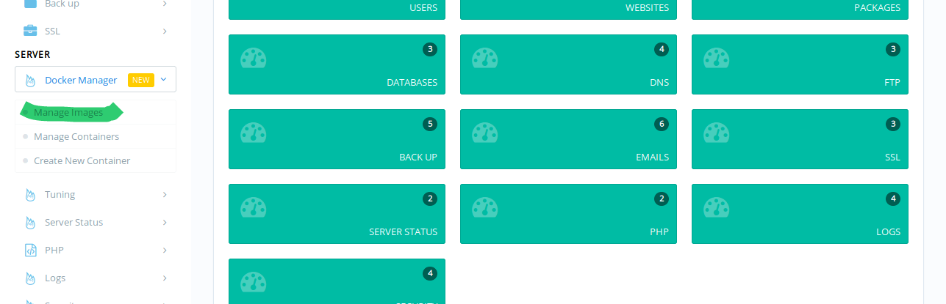

Once logged into CyberPanel, click Manage Images as highlighted in the image above. It will open the Manage Images window, where you can Search, Pull and Delete images.

Locally Available Images

Once you land on this page, you will see locally available images if any. (Previously pulled)

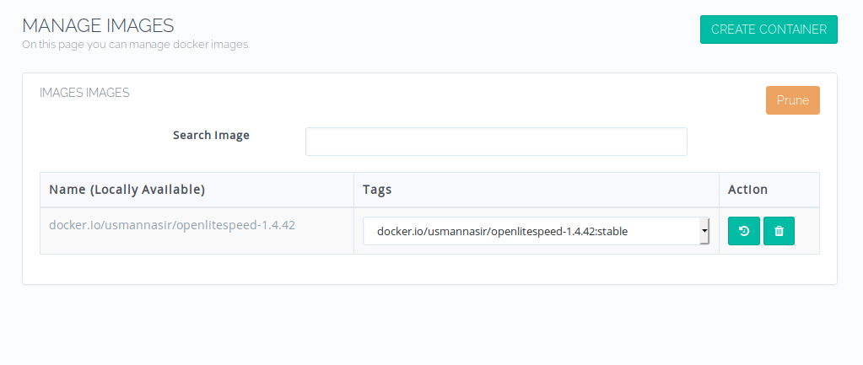

As you can see image usmannasir/openlitespeed-1.4.42:stable is already locally available on this server. You can Delete or view Image History by clicking the buttons under Action.

Search and Pull Images

On the same page you can also search for images available on Docker Hub (only public images will be shown in the search results).

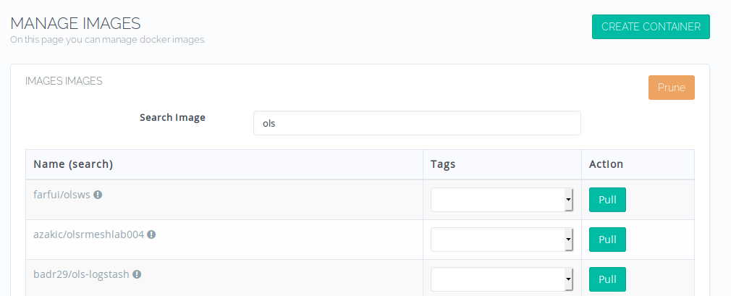

Put name of your image in the search bar so that related images can be fetched. From drop down you can select the tag and pull the image. Once pulled, this image will be listed as locally available.

Manually Pull Images

You can also download images manually via command line and they will be detected and listed as locally available image on Manage Images page. For example you have a private Docker repository, and you want to fetch an image from this repo.

You can login using docker login command on cli and pull the image using docker pull. Both public and private images can be pulled like that.

docker pull usmannasir/openlitespeed-1.4.42:stable

By the end of this tutorial, you already have your desired images locally available, you are now ready to create your first container out of it. 🙂

Tags:

# 3 – Create Docker Container

Created On

Last Updated On

bycyberpanel

Print

* [Main](https://cyberpanel.net/docs/)
* [Docker Manager](https://cyberpanel.net/docs/category/docker-manager-cyberpanel/)
* 3 - Create Docker Container

< All Topics

Before reading this tutorial you must read:

1. [Getting Started with CyberPanel Docker Manager.](https://cyberpanel.net/docs/1-getting-started-with-cyberpanel-docker-manager)
2. [Search/Pull/Download and Manage Docker Images.](https://cyberpanel.net/docs/2-search-pull-download-and-manage-docker-images)

After installing Docker and pulling your images, you are now ready to create your Docker Container. Docker containers are just running instances of Docker Images. In Dockers own words:

A container is a standard unit of software that packages up code and all its dependencies so the application runs quickly and reliably from one computing environment to another. A Docker container image is a lightweight, standalone, executable package of software that includes everything needed to run an application: code, runtime, system tools, system libraries and settings.

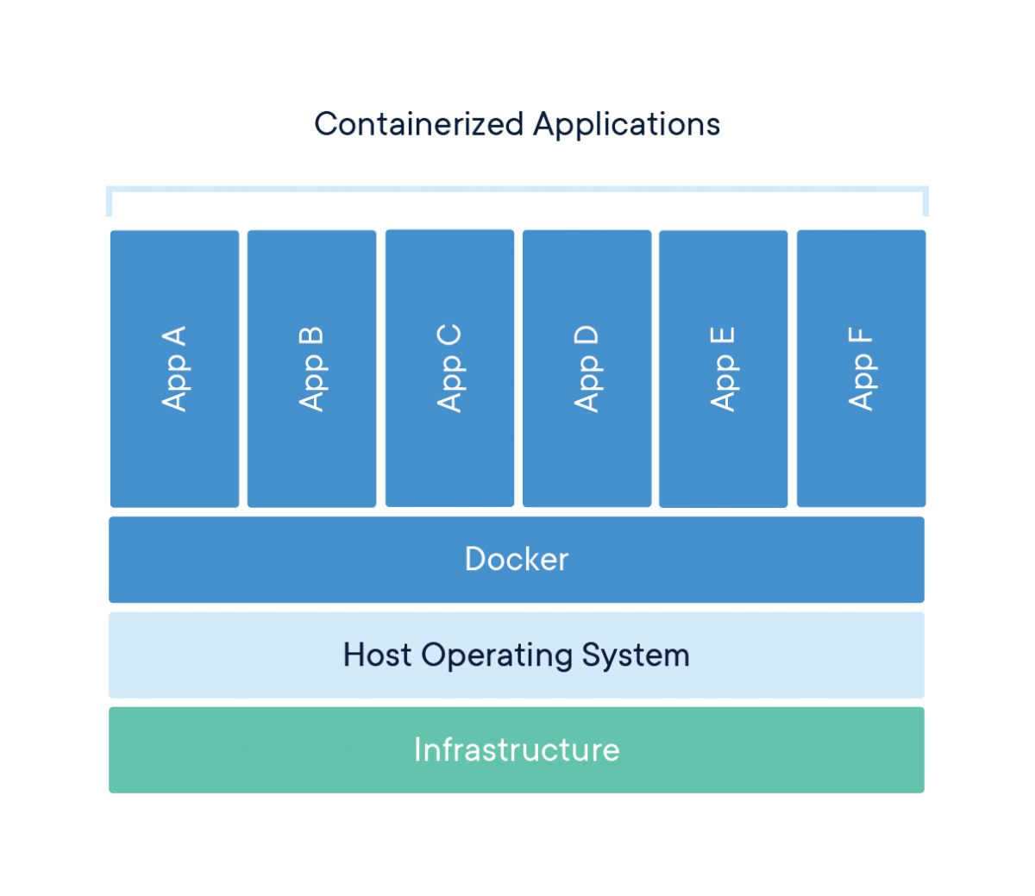

### Create New Container

Let see how we can create our Docker Container.



In CyberPanel Dashboard click Create New Container under Docker Manager in left sidebar.



You will be presented with list of locally available images (along with their tags) that you can use to create a Docker Container. We are going to use usmannasir/openlitespeed-1.4.42 image and its stable tag to create a new container. Its a simple image with OpenLiteSpeed installed in it. Once your image/tag is selected click Create.

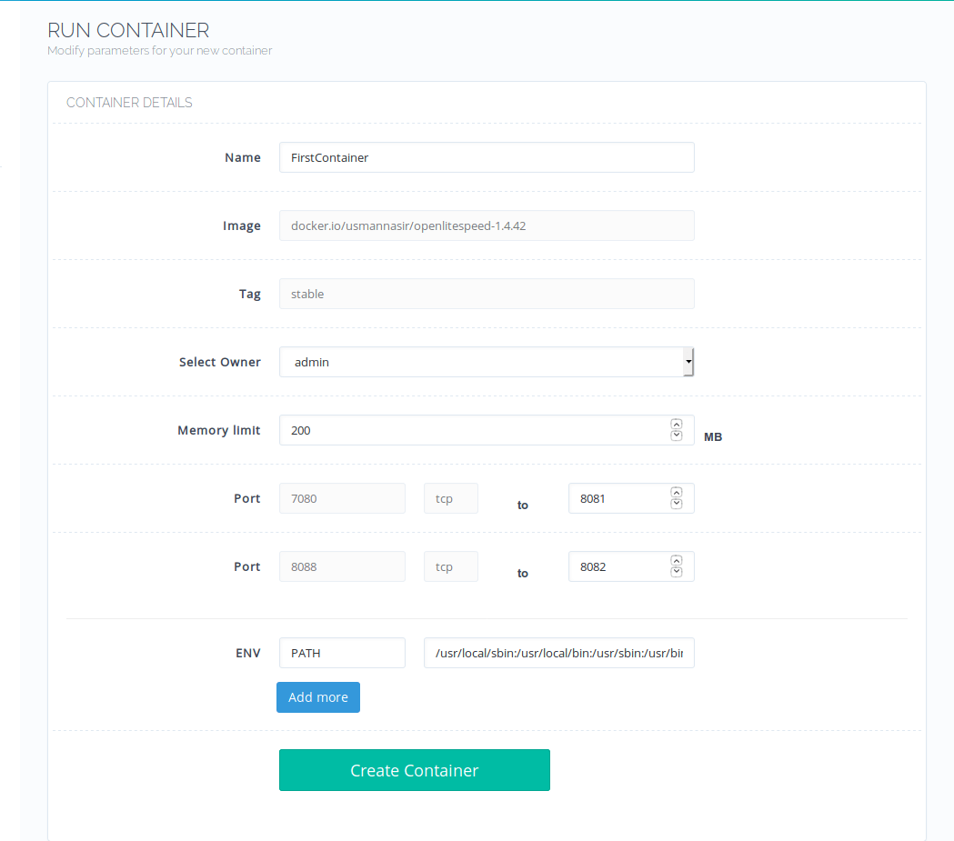

The image we choose above exposes port 7080 and 8088 you can map them to your host ports (we choose 8081 and 8082). Make sure that ports you choose are not used by any other process. Finally click Create Container. If creation went successful you will be redirected to the container page where you can manage different aspects of container (we will discuss that in our new document).

By default container is in created state, you can click start to change its state to running.

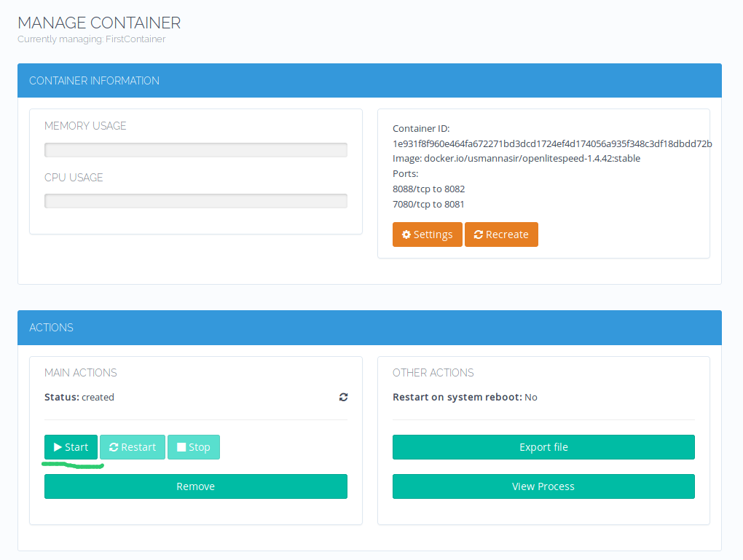

Once running visit: http://<ServerIP:8082 and you should see OpenLiteSpeed Welcome page.

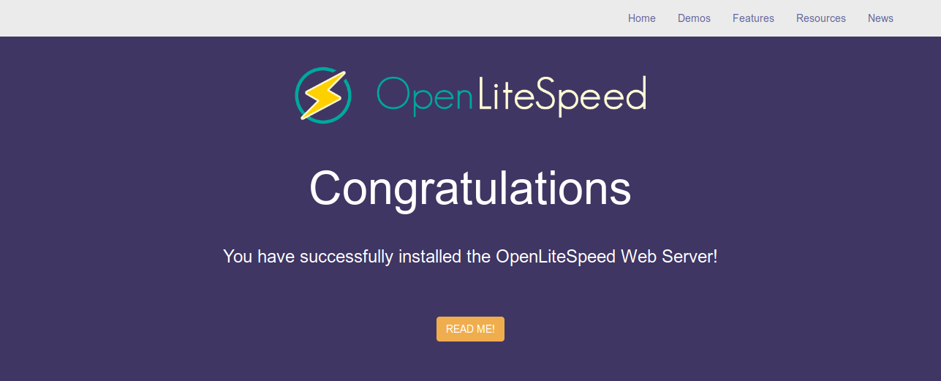

# 4 – Manage Docker Containers

Created On

Last Updated On

bycyberpanel

Print

* [Main](https://cyberpanel.net/docs/)
* [Docker Manager](https://cyberpanel.net/docs/category/docker-manager-cyberpanel/)
* 4 - Manage Docker Containers

< All Topics

Before reading this tutorial you must read:

1. [Getting Started with CyberPanel Docker Manager.](https://cyberpanel.net/docs/1-getting-started-with-cyberpanel-docker-manager)
2. [Search/Pull/Download and Manage Docker Images.](https://cyberpanel.net/docs/2-search-pull-download-and-manage-docker-images)
3. [Create Docker Container.](https://cyberpanel.net/docs/3-create-docker-container)

By the time you read this document, I assume that you have at least one container already created and running.

### Manage Containers

On CyberPanel Dashboard click Manage Containers under Docker Manager.

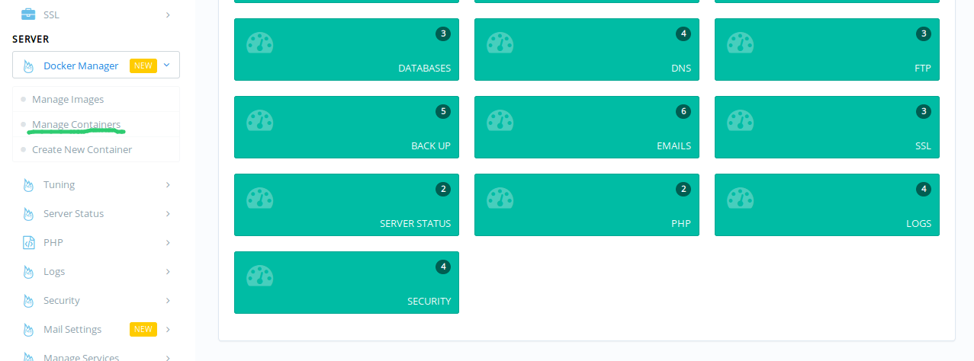

This will open the containers page. Where you can launch containers and manage them.

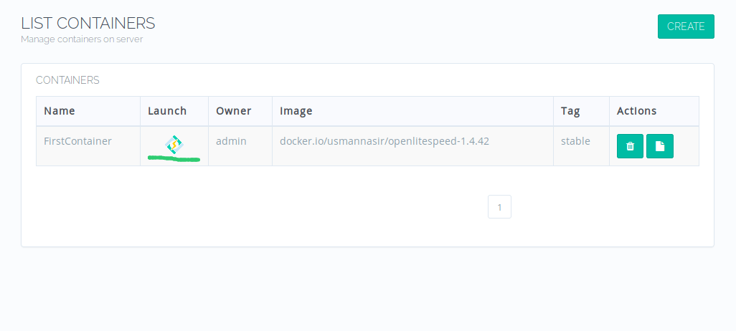

Once launched, rest is self-explanatory. You can:

1. Start/Stop Containers.
2. View CPU/Memory Usage.
3. View Port Mappings.
4. View processes inside the container.
5. View Container logs.



Tags:

https://cyberpanel.net/docs/4-manage-docker-containers/